PART-A

# Title of Micro Project: Artificial Fishpond Water Level Control System.

1. Brief Introduction:

A PLC (programmable logic controller) is an industrial digital computer which has been ruggedized and adapted for the control of manufacturing process, such as assembly lines, or robotic devices, or any activity that requires high reliability control and ease of programming and process fault diagnosis.

2.0 Aim of the Micro Project: - To develop and test a ladder diagram for Artificial Fishpond Water Level Control System.

3.0 Action Plan

|  |  |  |  |  |
| --- | --- | --- | --- | --- |
| Sr.  No. | Details of Activity | Planned Start Date | Planned Finish Date | Name of Responsible Team Members |
| 1 | Formation of group | 8/07/2019 | 10/07/2019 |  |
| 2 | Allocation of project | 11/07/2019 | 15/07/2019 |  |
| 3 | Study of the topic | 16/07/2019 | 25/07/2019 | Satyajeet |
| 4 | Practical Performance | 26/07/2019 | 02/08/2019 | Aman |
| 5 | Theoretical verification | 03/08/2019 | 07/08/2019 | All member |
| 6 | Preparation of report | 08/08/2019 | 20/08/2019 | All member |
| 6i77 | Submission of project | 21/08/2019 | 30/08/2019 | All member |

4.0 Resources Required (Such as raw material, some machining facility, software etc.)

|  |  |  |  |  |
| --- | --- | --- | --- | --- |
| Sr.  No. | Name of Resource/Material | Specifications | Qty | Remarks |
| 1 | PLC | PLC system Hardware and Software for Ladder  Programming. | 1 |  |
| 2 | Computer | Intel Process core 13 or 17 | 1 |  |

PART-B

Title of Micro Project: Artificial Fishpond Water Level Control System.

1.0 Brief Description: A programmable logic controller (PLC) or programmable controller is an industrial digital computer which has been ruggedized and adapted for the control of manufacturing processes, such as assembly lines, or robotic devices, or any activity that requires high reliability control and ease of programming and process fault diagnosis.

In this project, Delta PLC is used for controlling the inputs and outputs. Input supply to

The PLC is given through a SMPS. The rating of the SMPS is 24V DC. The PLC used here is a

Compact PLC which has fixed number of inputs and outputs. In this kind of PLC model, the CPU

Contain 8 digital inputs and 8 digital outputs. Water level sensor has been used to sense the water level. Toggle switches are used to serve the purpose of some inputs to the PLC.

2.0 Aim of Micro Project: To develop and test a ladder diagram for Artificial Fishpond Water Level Control System.

1. Course Outcomes Integrated: - Maintain PLC based process control system.

4.0 Resources Required (Such as raw material, some machining facility, software etc.)

|  |  |  |  |  |
| --- | --- | --- | --- | --- |
| Sr.  No. | Name of Resource/Material | Specifications | Qty | Remarks |
| 1 | PLC | PLC system Hardware and Software for Ladder  Programming. | 1 |  |
| 2 | Computer | Intel Process core 13 or 17 | 1 |  |

5.0 Actual Procedure followed

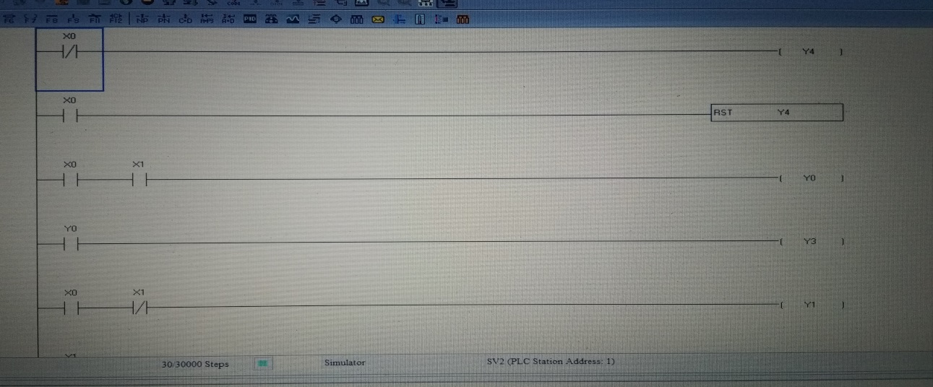

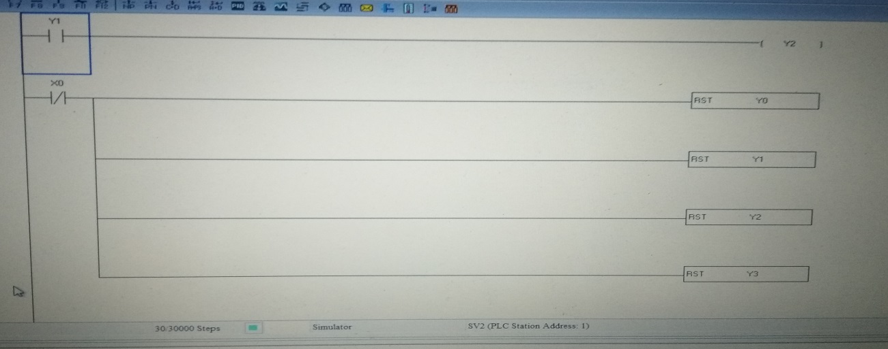

* Function :-

1. If X0=0= All ok.
2. If X0=1= Not ok.
3. If X1=0= Water level low.
4. If X1=1= Water level high.
5. If Y0= Water drain.
6. If Y1= Water feed.
7. If Y2= Alarm light.
8. If Y3= Alarm (buzzer).
9. If Y4= All ok.

* In the above program, 0 is normally closed, X0 and X1 is the level sensor, Y0 is the drain pump, Y1 is the feed pump, Y2 is the Alarm light, Y3 is the Alarm, and Y4 is the all ok.
* Working: -

Here we considered one artificial fishpond, two level sensors and two pumps for system monitor & control. Here we write a program that will control whole system. System will maintain normal level and it does not allow water level to go up or down to maintain the normal level. If water level goes down from the normal level then system will feed water in the fishpond and if water level goes up from the normal level then system will drain water from the fishpond.In this ladder diagram, X0 is 0 the water level is OK. When X1 become 0 the water level is low and X0 become 1 then the feeding pump is start (Y1) and Y3 is ON (Alarm light). When X1 become 1 the water level is high then Drain pump is start (Y0) and Y3 is ON (Alarm).

6.0 Output of the micro project:-

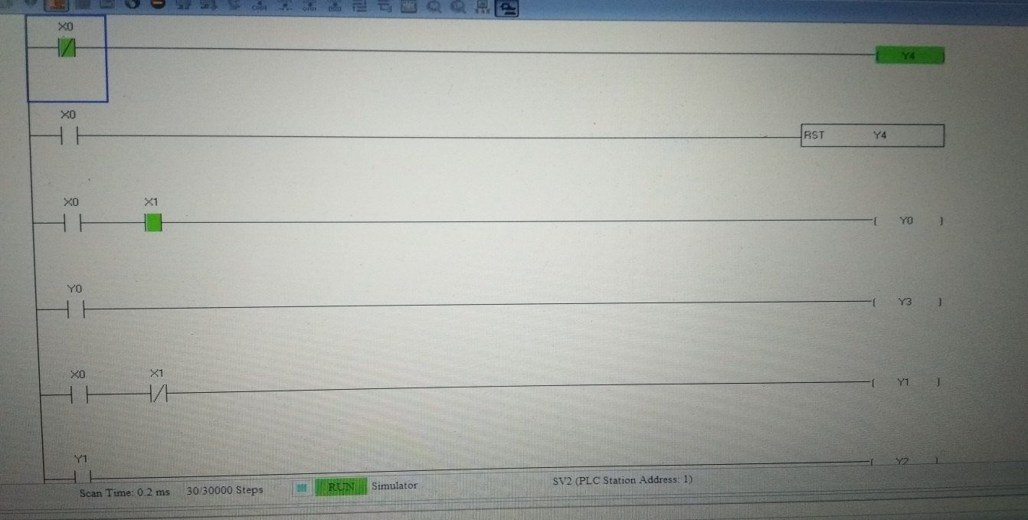

7.0 Skill Developed/Learning out of this Micro Project

1. Design of the ladder diagram :

By read statement and make the ladder diagram.

1. Trouble shooting the ladder diagram:

After compile the program the error is come trouble shoot the program.

Annexure-IIA

Name of Student: Aman Shaikh Enrolment No: 1710900104

Name of Programme: Electronic and telecommunication Semester: 5

Course Title: Control System and PLC Code: 22531

Title of the Micro Project: Artificial Fishpond Water Level Control System.

Course Outcomes Achieved: Maintain PLC based process control system.

# Micro Project Evaluation Sheet

|  |  |  |  |  |
| --- | --- | --- | --- | --- |
| Process Assessment | | Product Assessment | | Total Marks 10 |
| Part-A  Project Proposal  (Mark-2) | Project  Methodology  (Mark-2) | Part-B  Project Report/  Working Model  (Marks-2) | Individual  Presentation/  Viva  (Marks-4) |
|  |  |  |  |  |

Note: Every course teacher is expected to assign marks for group evolution in first 3 columns and individual in 4th columns for each group of students as per rubrics.

Comments/Suggestions about team work/leadership/inter-personal communication (if any)

----------------------------------------------------------------------------------------------------------------------------

----------------------------------------------------------------------------------------------------------------------------

Any other Comments:

----------------------------------------------------------------------------------------------------------------------------

Name and Designation of Faculty Members

Signature:

Annexure-IIA

Name of Student: Satyajeet Nirmal Enrolment No: 1810900120

Name of Programme: Electronic and telecommunication Semester: 5

Course Title: Control System and PLC Code: 22531

Title of the Micro Project: Artificial Fishpond Water Level Monitoring System.

Course Outcomes Achieved: Maintain PLC based process control system.

# Micro Project Evaluation Sheet

|  |  |  |  |  |
| --- | --- | --- | --- | --- |
| Process Assessment | | Product Assessment | | Total Marks 10 |
| Part-A  Project Proposal  (Mark-2) | Project  Methodology  (Mark-2) | Part-B  Project Report/  Working Model  (Marks-2) | Individual  Presentation/  Viva  (Marks-4) |
|  |  |  |  |  |

Note: Every course teacher is expected to assign marks for group evolution in first 3 columns and individual in 4th columns for each group of students as per rubrics.

Comments/Suggestions about team work/leadership/inter-personal communication (if any)

----------------------------------------------------------------------------------------------------------------------------

----------------------------------------------------------------------------------------------------------------------------

Any other Comments:

----------------------------------------------------------------------------------------------------------------------------

Name and Designation of Faculty Members

Signature: